**Prepared by Quad Services**

**ABN: 58 000 308 592**

**Provision of Cleaning Services**

**SP37634 - 39 Stanley Street, Bankstown**

**Prepared for**



Table of Contents

EXECUTIVE SUMMARY 5%20Quad\Quotation\Q)%20Saved\NSW\A\Alcorp%20Strata%20Management%20%20SP37634%2007%2005%202015%20IS.docx#_Toc419982790)

DETAILS OF OUR PROPOSAL, PRICE AND SPECIFICATIONS 8%20Quad\Quotation\Q)%20Saved\NSW\A\Alcorp%20Strata%20Management%20%20SP37634%2007%2005%202015%20IS.docx#_Toc419982791)

Price Schedule 9

Optional Toilet Consumables 10

Cleaning Specification 11

Conditions of Contract 13

Acceptance 14

REFERENCES 15%20Quad\Quotation\Q)%20Saved\NSW\A\Alcorp%20Strata%20Management%20%20SP37634%2007%2005%202015%20IS.docx#_Toc419982797)

ACCOUNT MANAGEMENT QUAD KEY PERSONNEL CONTACTS 17%20Quad\Quotation\Q)%20Saved\NSW\A\Alcorp%20Strata%20Management%20%20SP37634%2007%2005%202015%20IS.docx#_Toc419982798)

Quad Operations Structure 18

Operations Management Team 20

WHS and Environment Team 21

Office Support Teams 22

QUAD SERVICE METHODOLOGY 23%20Quad\Quotation\Q)%20Saved\NSW\A\Alcorp%20Strata%20Management%20%20SP37634%2007%2005%202015%20IS.docx#_Toc419982803)

Quality Assurance 24

Quad Operations Model 25

Issue Prevention and Resolution 28

Customer Care and Close the Loop Process (CLP) 30

Onsite Operations and WHS Documentation 31

Equipment and Materials 32

Training and Development 33

Roles and Responsibilities 34

Staff Uniforms & Identification 36

START UP PLANNING 37%20Quad\Quotation\Q)%20Saved\NSW\A\Alcorp%20Strata%20Management%20%20SP37634%2007%2005%202015%20IS.docx#_Toc419982813)

CONTRACT REPORTING 40%20Quad\Quotation\Q)%20Saved\NSW\A\Alcorp%20Strata%20Management%20%20SP37634%2007%2005%202015%20IS.docx#_Toc419982814)

Site Customised Inspection Report 42

Annual Action Plan 44

Management Review Meetings 45

QUAD SECURITY AND MAINTENANCE SERVICE 46%20Quad\Quotation\Q)%20Saved\NSW\A\Alcorp%20Strata%20Management%20%20SP37634%2007%2005%202015%20IS.docx#_Toc419982818)

Security Services 47

Maintenance Services 48

AFFILIATIONS & AWARDS 49%20Quad\Quotation\Q)%20Saved\NSW\A\Alcorp%20Strata%20Management%20%20SP37634%2007%2005%202015%20IS.docx#_Toc419982821)

WHS INFORMATION AND ENVIRONMENTAL SUSTAINABILITY 54%20Quad\Quotation\Q)%20Saved\NSW\A\Alcorp%20Strata%20Management%20%20SP37634%2007%2005%202015%20IS.docx#_Toc419982822)

WHS Accreditation 55

Environment Accreditation 58

**Quad Services Pty Ltd**

ACN: 000 308 592 ABN: 58 000 308 592

Master License Number: 409648021

HO: 12 Carlotta Street Artarmon NSW 2064

(o) 02 8425 6900 | (f) 02 8425 6960

www.quadservices.com.au

21st May, 2015

**Attention: Ms Cheryl Glanville**

Strata Manager

Alcorp Strata Management

2-6 Limekiln Street

LUGARNO NSW 2210

**Re: Provision of Cleaning Services for Alcorp Strata Management located at**

**39 Stanley Street BANKSTOWN 2200**

Dear Ms Glanville,

Thank you for the opportunity to provide you with our quotation for the cleaning of your premises.

Quad established its Sydney office in 1972 and currently provide services to over 400 clients in the Sydney Metropolitan area. Our Sydney Operations team includes two Group General Managers and 19 area Operations Management personnel (General Managers and Operations Managers).  They have extensive knowledge and skills in the cleaning industry. In addition to this Operations Management structure, the team has the backing of our Support Team in the areas of WHS, Environment, Human Resources, IT, Customer Care, Finance and Administration. This depth of management means that our team for your sites will have a significant support in all operational matters to ensure an ongoing consistent standard of service.

In our site inspection it was evident that the toilets require initial work to be done to raise it to an acceptable standard. Should our proposal be accepted we would deep scrub the toilet floors at no cost to Alcorp Strata Management within the first 2 weeks of service.

Our focus is to provide a consistent service that meets the cleaning requirements of your company. Quad has a three part client focused strategy that achieves this. First, the consistent application of a proven operations model for a quality cleaning service. Second, constant measurement of client satisfaction to confirm we are achieving agreed standards of service. Third, a system of response to any defects that ensures they are immediately addressed and rectified to client satisfaction.

In this proposal we have provided:

* Price and cleaning specifications.
* References of current clients. Further references can be provided on request.
* Details of the team that will provide our service and our operations methodology:
  + Information on the key personnel that will serve your site.
  + The Quad operations methodology to manage and supervise the cleaning of your premises.
  + Start-up planning to ensure a seamless transition.
  + Contract reporting.
    - Supporting information about Quad:
  + Quality Assurance, WHS and Environmental accreditations and systems.
  + Affiliations and Awards.

Your Operations Manager; Steve Djuric, is based in the region. The Operations Manager has close support from the General Manager; Jose Pimentel, who will monitor cleaning standards and be available at all times. Details of the Operations Team that will be responsible for ensuring your satisfaction are provided in the Account Management section. I would be happy to introduce this team to you at your convenience.

Quad received the highly recommended award in the “**2015 Australian Achievers Awards for Excellence in Customer Service for Cleaning and Maintenance Services and Supplies”** in the National division. We received a score of 91.84% customer satisfaction in this independent award, based on assessment ratings from our clients. In 2014 we were the winner of this award. Quad has also been the winner of the “**Contract Cleaning Company of the Year**” Award on two separate occasions in recent years.  This is an award for industry excellence presented by the Building Services Contractors Association of Australia (BSCAA).

We have endeavoured to provide a cost effective proposal that meets your cleaning requirements. We can provide more information on any aspect of our service, if required. Flexibility in tailoring our service to the changing needs of our clients is an integral element of our service. If any part of our proposal does not meet your requirements we would be happy to review and adjust it to meet your needs.

We look forward to discussing our proposal with you.

Yours sincerely,

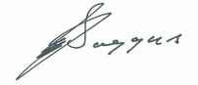

**Ian Saggus**

**Business Development Manager**

**0413 129 782| isaggus@quadservices.com.au**

# EXECUTIVE SUMMARY

Quad, an Australian company established in 1972, has stable long term ownership with strong senior management and operations teams.  Through organic growth, Quad has become a significant provider of quality cleaning and associated services across Australia.

Our methodology to ensure a consistent delivery of service that meets the requirements of the cleaning specification is summarised in the Quad Operations Model detailed in our proposal.  The key elements of this model are:

1. Having local Operations Managers in close proximity to client sites for prompt response and supervision, particularly for new or relief cleaners. This enables effective regular supervision and for the Operations Manager to quickly attend your site in response to any requests.
2. Limiting the number of sites for the Operations Manager to service. Too many sites dilute attention to each site.
3. Focus on the right site set up, the right people, supervision, equipment, and cleaner scheduling, with clear duty schedules. Long term consistent service and relationship is built on the foundation of appropriate onsite resources that are effectively supervised.
4. A team that understands and is fully competent in the site security requirements, including key security and lockup procedures.
5. Induction of all staff to site requirements, and ongoing staff evaluation and training to ensure staff are competent to perform the tasks required at the site.
6. Three levels of offsite management for consistent site overview.  Regular General Manager oversight provides an additional external management tier for review of standards and a senior tier for client to raise any issues. This depth of offsite support ensures consistency of service when planned and unplanned manager absences occur. Group General Manager provides additional ongoing review of service quality and offsite support.
7. The Operations Manager and General Manager have the authority to make decisions to quickly meet customer needs.  At Quad they do not need to await head office approval to act to meet client needs.
8. Regular inspections using a report customised to site requirements. An ongoing second level of auditing of these reports to ensure they are an effective quality control mechanism.
9. An independent customer feedback system that enables us to constantly measure client satisfaction, identify potential concerns early and ensure timely rectification to client satisfaction.  Each month client nominated site personnel are contacted for feedback.  Any client concern initiates our CLP process and this keeps the issue in front of senior Quad management until issues are rectified to client satisfaction.  The Operations Manager will contact the client on the same day, arrange immediate rectification and then inspect the work with the client to confirm satisfaction.
10. Effective communication tools to facilitate immediate communication between Quad staff and our clients.
11. Customer service focus.  All Quad staff are trained to focus on client satisfaction and to adjust our service to meet client needs.
12. Quad maintains third party accreditation of our WHS, Environmental and Quality Management Systems. Services are provided in accordance with these systems with ongoing review and immediate support from our Compliance Department.
13. Effective periodical performance review meetings to ensure clear communication and understanding of client assessment of our performance on a range of agreed criteria.
14. Ongoing senior management review, for continuous improvement and to ensure all elements are functioning optimally to achieve client satisfaction.

Each of these elements of the Quad Model is important to consistent long term service delivery. At Quad we have a disciplined adherence to this model. We constantly measure client satisfaction and immediately respond to defects to ensure prompt rectification.

Details of the local operations team, the support teams and supervision structure are provided in the account management section. Our local Operations Management team have in depth experience in managing a wide variety of client requirements and are supported by our regional and national Operations Management team.

We have a detailed start-up plan to ensure a seamless transition and we would work with your representative(s) to tailor this to the specific needs of your site.

All managers provide daily online reporting of any requests or issues relating to the service being provided so senior management can provide immediate assistance. Senior management teams then meet monthly to review the process as part of our continuous improvement.

Quad is a member of Green Building Council of Australia, Building Service Contractors Association of Australia, Property Council of Australia and Facility Management Association of Australia.

Quad has a record of no time lost through industrial relations disputes and maintains a professional relationship with union bodies. Whenever there is a case of employee dissatisfaction we act quickly; understand from employee perspective; review systems and resources, and rectify where appropriate.

Our staff are subject to work visa verification and police checks. Additional screening is provided as required. All staff wear uniforms, display identification and are fully covered for Workers Compensation and Public Liability.

Quad provides a 24/7 service and guarantees to immediately respond to any client requests.

The Quad philosophy is to achieve long term client relationships based upon providing a quality cost effective service. We are constantly seeking ways to improve our service, add value to our service to benefit our clients and reduce costs to our clients where possible. This is an ongoing agenda item in the management review meetings with client representatives.

# DETAILS OF OUR PROPOSAL, PRICE AND SPECIFICATIONS

## Price Schedule

**Alcorp Strata Management**

**39 Stanley Street, BANKSTOWN**

|  |  |  |
| --- | --- | --- |
| **Description** | **Price Per Week** | **Price Per Annum** |
| General Cleaning | $177.18 | $9,213.36 |

|  |  |
| --- | --- |
| **Total** | **$9,213.36** |
| GST | $921.34 |
| **Invoice** | **$10,134.70** |

Payment terms for this quotation are based upon a total per annum price divided into 12 equal monthly invoices of $767.78 + GST.

In our site inspection it was evident that the toilets require initial work to be done to raise it to an acceptable standard. Should our proposal be accepted we would deep scrub the toilet floors at no cost to Alcorp Strata Management within the first 2 weeks of service.

## Optional Toilet Consumables

|  |  |  |  |  |
| --- | --- | --- | --- | --- |
| **Product Description** | **Units/ Carton** | **Price** | **GST** | **Price incl GST** |
| **Toilet Rolls** | | | | |
| Tork Advanced Toilet Roll 2 ply 400 sheets | 48 | $40.00 | $4.00 | $44.00 |
| Tork Universal Toilet Roll 1 ply 1000 sheets | 48 | $64.14 | $6.41 | $70.55 |
| Trusoft Recycled Toilet Roll 2 ply 400 sheets (10 centimetres x 10 centimetres) | 48 | $25.00 | $2.50 | $27.50 |
| Trusoft Recycled Toilet Roll 2 ply 400 sheets (Individual Wrap) (10 x 10 centimetres) | 48 | $23.30 | $2.33 | $25.63 |
| Trusoft Jumbo Toilet Roll 2 ply 300 metres | 8 | $22.14 | $2.21 | $24.35 |
| Trusoft Jumbo Toilet Roll Recycled 2 ply 400 metres (9.5 centimetres x 400 m) | 6 | $23.75 | $2.38 | $26.13 |
| Trusoft Jumbo Toilet Roll Recycled 1 ply 500 metres (9.5 centimetres) | 8 | $23.75 | $2.38 | $26.13 |
| Trusoft Jumbo Toilet Roll Recycled 1 ply 650 metres (9.5 centimetres) | 6 | $22.14 | $2.21 | $24.35 |
| Regal Toilet Roll 2 ply 250 sheets | 48 | $22.40 | $2.24 | $24.64 |
| Trusoft Toilet Roll Recycled 1 ply 850 sheets (10 centimetres x 10 centimetres) | 48 | $24.86 | $2.49 | $27.35 |
| Regal Toilet Roll 2 ply 400 sheets (10 centimetres x 11 centimetres) | 48 | $26.85 | $2.69 | $29.54 |
| Regal Toilet Roll Recycled 2 ply 700 sheets | 48 | $39.38 | $3.94 | $43.31 |
| **Toilet tissue (special dispensers required)** | | | | |
| Kimberley Clark Deluxe Toilet Tissue Roll 2 ply 400 sheets | 48 | $61.88 | $6.19 | $ 68.06 |
| Regal Interleaved Toilet Tissue Recycled 2 ply 240 sheets (10 x 21 centimetres) | 36 | $27.74 | $2.77 | $30.51 |
| Regal Interleaved Toilet Tissue 2 ply 250 sheets (9 x 19 centimetres) | 36 | $27.74 | $2.77 | $30.51 |
| **Facial tissues** | | | | |
| Kimberley Clark Iso Wipes | 12 | $131.78 | $13.18 | $144.96 |
| Regal Facial Tissue 2 ply 100 sheets (19 centimetres x 20 centimetres) | 48 | $33.32 | $3.33 | $36.65 |
| Regal Facial Tissue 2 ply 200 sheets (19 centimetres x 20 centimetres) | 32 | $35.08 | $3.51 | $38.59 |
| **Hand towels** | | | | |
| Tork Advanced Hand Towel Ultra Slim 150 sheet | 16 | $41.25 | $4.13 | $45.38 |
| Tork Universal Slim Hand Towel 250 sheets | 16 | $42.57 | $4.26 | $46.83 |
| Tork Universal Roll Towel 90 metres | 16 | $35.17 | $3.52 | $38.69 |
| Tork Premium Kitchen Roll 60 sheets | 12 | $22.61 | $2.26 | $24.87 |
| Trusoft Centre feed Towel 300 metres x (20 centimetres x 300 metres) | 6 | $33.55 | $3.36 | $36.91 |
| Regal Gold Ultra Slim Hand Towel 150 sheets (24 centimetres x 23.5 centimetres) | 16 | $32.33 | $3.23 | $35.56 |
| Regal Gold Tad Interleaved Hand Towel 150 sheets | 16 | $29.80 | $2.98 | $32.78 |
| Regal Gold Tad Slimline Hand Towel 200 sheets | 16 | $39.73 | $3.97 | $43.70 |
| Regal Interleaved Towel 150 sheets (24 centimetres x 24 centimetres) | 16 | $28.89 | $2.89 | $31.78 |
| Regal Interleaved Towel Recycled 150 sheets (24 centimetres x 24 centimetres) | 16 | $26.17 | $2.62 | $28.78 |
| Regal Slim Hand Towels 250 sheets (23 centimetres x 24centimetres) | 16 | $34.72 | $3.47 | $38.19 |
| Regal Compact Hand Towel 120 sheets (20.5 centimetres x 24.5 centimetres) | 20 | $34.37 | $3.44 | $37.80 |
| Regal Large Interleaved Hand Towel 100 sheets (23 x 36.5 centimetres) | 24 | $34.95 | $3.50 | $38.45 |
| Trusoft Centreline Towel 300 metres | 4 | $30.23 | $3.02 | $33.25 |
| Trusoft Roll Towel 80 metres | 16 | $29.65 | $2.96 | $32.61 |
| **Soap** | | | | |
| Soft As Soap Lavender 250 millilitres | 24 | $59.83 | $5.98 | $65.82 |
| Tork Hand Cleanser 1000 500 millilitres | 12 | $87.14 | $8.71 | $95.86 |
| Deb Azure Foam Wash 1 litre Cartridge | 6 | $72.70 | $7.27 | $79.97 |
| Kimberley Clark Everyday Use Hand Cleanser 1 litre | 6 | $96.11 | $9.61 | $105.72 |
| Active 3C Waterless Sanitiser Gel x 5 litres | 1 | $69.73 | $6.97 | $76.70 |
| Active 3C Hygienic hand Soap 5 litres | 1 | $18.64 | $1.86 | $20.50 |
| Regal Soft Like Soap (White) 5 litres | 1 | $15.62 | $1.56 | $17.18 |
| Regal Soft Like Soap (White) 15 litres | 1 | $53.69 | $5.37 | $59.06 |
| Regal Pink Lotion Hand Soap 15 litres | 1 | $33.76 | $3.38 | $37.14 |
| Regal Pink Lotion Hand Soap 5 litres | 1 | $11.53 | $1.15 | $12.69 |

## Cleaning Specification

**Alcorp Strata Management**

**39 Stanley Street, BANKSTOWN**

*The cleaning service will be carried out three days a week from Mondays, Wednesdays and Fridays excluding public holidays.*

*Should a public holiday arise on one of these days cleaning will be carried out the following working day.*

### Areas to Clean

|  |  |  |
| --- | --- | --- |
| **Ground Floor** | **Level 1** | **Level 2** |
| • Foyer | • Female Toilets | • Common Areas |
|  | • Male Toilets | • Male Toilets |
|  | • Stairs | • Female Toilets |
|  | • Common Areas |  |

### Cleaning Specification

|  |  |
| --- | --- |
| **ENTRY & FOYER** |  |
| Sweep the exterior entry | 3 x Weekly |
| Hot wash the exterior entry | 3 x Weekly |
| Dust foyer furniture & fittings | 3 x Weekly |
|  |  |
| **TOILETS, SHOWERS & LOCKER ROOM** |  |
| Sweep & hot wash floor surface | 3 x Weekly |
| Clean & disinfect pans, seats, urinals, basins, fittings & showers | 3 x Weekly |
| Remove marks from doors & walls | 3 x Weekly |
| Clean mirrors | 3 x Weekly |
|  |  |
| **RUBBISH** |  |
| Empty bins throughout all public & administration areas | 3 x Weekly |
| Empty smokers trays | 3 x Weekly |
| Empty bins in toilet areas | 3 x Weekly |
| Replace liners in bins | As required |
| Deposit rubbish in agreed location | 3 x Weekly |
|  |  |
| **CARPETED FLOORS** |  |
| Vacuum entire floor area | 3 x Weekly |
| Vacuum corners & edges | Weekly |
| Spot clean stains or marks | As required |
| **FURNITURE & FITTINGS** |  |
| Wipe all light switches | 3 x Weekly |
| Dust all ledges & skirtings | Weekly |
| Dust partitions & vertical surfaces | Weekly |
| Dust door jambs | Weekly |
|  |  |
| **FIRE STAIRS / STAIRS** |  |
| Vacuum & remove stains | 3 x Weekly |
| Clean & polish handrails | 3 x Weekly |
| Clean any glass panels | 3 x Weekly |
| Detail clean step treads | Weekly or as required |
| Dust all ledges etc | Weekly or as required |
|  |  |

## Conditions of Contract

**BETWEEN**

**Quad Services and Alcorp Strata Management**

**1. INSURANCES:**

We carry the following Insurances:

Workers Compensation

Company: CGU

Cover: As Per the Act

Public Liability

Company: CGU

SUA

Cover: $50,000,000.00

**2.** **INVOICING ARRANGEMENTS:**

This quotation is based upon a per annum price divided into 12 equal monthly invoices. The parties agree that the contract price includes the Goods and Service Tax (GST) as reflected in the price schedule.

**3. TERMS OF PAYMENT:**

Calendar monthly Invoices are rendered on the 1st day of the current month, for payment on the 15th day of the month. Alternatively, arrangements can be made for weekly/fortnightly terms - 7 days in arrears.

**4. PERIOD OF AGREEMENT:**

This agreement is open ended, terminable by either party on one (1) month’s notice in writing.

**5. STATUTORY & PUBLIC HOLIDAYS:**

The cleaning service will be performed on the days outlined in the specifications.

**6. MACHINERY, EQUIPMENT & MATERIALS:**

Quad will supply all Machinery, Equipment & Materials utilised on site (except toilet requisites, unless otherwise arranged) to provide the standard of cleaning set out in the attached specifications.

**7. RISE & FALL CLAUSE:**

This price is fixed for twelve (12) months from the commencement of services. After this time the contract price will be adjusted according to any statutory and/or award increases.

## Acceptance

Alcorp Strata Management

2-6 Limekiln Street

LUGARNO NSW 2210

Date:....................

Quad Services Pty Ltd

Head Office

12 Carlotta Street

ARTARMON NSW 2064

**ACCEPTANCE OF CLEANING PROPOSAL FOR 39 STANLEY STREET, BANKSTOWN 2200**

Dear Ian,

This is to confirm we are pleased to accept your quotation dated 21st May, 2015 at a cost of $9,213.36 per annum plus GST. We would like your service to commence on ......../........../...........

*In Addition, please supply further information on the following services:*

Toilet Requisites Waste Removal Sanitary Bins

Strip and seal vinyl  Carpet Shampoo  Grounds Maintenance

Security Pest Control  Appliance Test and Tag

Waste Management  Laundry  Glass Collection and Kitchen Hands

Yours Sincerely,

**Alcorp Strata Management**

**Cheryl Glanville**

**Strata Manager**

|  |  |  |
| --- | --- | --- |
| Authorised By: |  |  |
|  |  |  |
| Name of Organisation: |  |  |
|  |  |  |
| ACN/ABN of Organisation: |  |  |

**For an immediate response please send to head office on**

**fax: 02 8425 6960 or email support@quadservices.com.au**

## 

# REFERENCES

**Examples of Current Work & References**

|  |  |
| --- | --- |
| **Morgan Industrial Carbon, Revesby, NSW**  **Peter Kickert, Production Manager – 02 9772 5631** | |
|  | * Quad has been providing cleaning services to this site since 2004. * Areas serviced include: * Foyer/reception areas and canteen * Administration offices and boardroom * Manufacturing and dispatch factory areas; and * First Aid office, amenities and car park. * As part of our service we machine scrub the manufacturing and dispatch floor weekly. * Quad also provides: * Toiletry and sanitary services * External and internal window and partition cleaning;  and * Carpet and upholstery steam cleaning. |
| **Jones Lang LaSalle, 19 Harris Street, Pyrmont, NSW**  **Andrew Reed, Building Operations Manager – 0424 200 996** | | |
|  | * Quad currently cleans a number of sites for Jones Lang Lasalle (JLL) throughout NSW and ACT. * We commenced cleaning at this commercial office site in 2009. * We service all internal common areas across the 6 floors, along with the external car parks and driveways * Areas serviced in this multi-level establishment include:   + Gym   + External glazing   + Loading Docks   + Balconies   + Toilets / Showers   + Kitchens * We also provide the following as needed services:   + Window cleaning   + Carpet shampoo   + Strip and seal floors | |

|  |  |
| --- | --- |
| Henroth Properties, 180 Ocean Road, Edgecliff, NSW  Peter Ryder, Building Supervisor – 0409 911 088 | |
|  | * Quad has been providing cleaning services to this site since 1996. * The areas serviced include all common areas and tenancies over 9 levels, along with cleaning of the basement car parking areas. * Additional services include: * external and internal window cleaning; and * waste removal. * Both morning and night cleaning services are provided five days per week. |

More References can be provided on request.

ACCOUNT MANAGEMENT QUAD KEY PERSONNEL CONTACTS

## Quad Operations Structure

**Chief Executive Officer**

**Group General Manager**

**Local General**

**Manager**

**Local Operations Manager**

**Supervisor**

**Cleaners**

**QA Compliance Manager**

**EH & S**

**Manager**

**Client**

**The following pages provide a brief introduction to the Local Operations team and Key Personnel for your contract.**

Quad Services Sydney Metropolitan Area

Operations Management Structure

The management positions below are all Quad field Managers- This chart does not include site supervisors or site managers

## Operations Management Team

|  |
| --- |
| Steve Djuric.jpg**Steve Djuric**  **Operations Manager**  0403 575 914  [sdjuric@quadservices.com.au](mailto:sdjuric@quadservices.com.au)    Steve, your local Operations Manager, has more than 19 years’ experience in the cleaning industry and:   * Has completed Certificate IV in Asset Maintenance (Cleaning Management). * Has also completed a range of Quad management training, WHS & infection control, Environmental Management and Quality Management programs. * Will conduct regular inspections of the premises, to ensure our service remains at a consistently high standard.   Customer satisfaction is a high priority to Steve, and he will regularly visit your premises to liaise with site representatives.  Quad is focused on providing competent staff and Steve will ensure staff inductions and training are carried out in accordance with site requirements.  Steve is supported by Quad’s local General Manager, Jose Pimentel, and a team of specialist support personnel. |

|  |
| --- |
| Jose Pimentel.jpg**Jose Pimentel**  **General Manager**  0411 476 647  Jpimentel@quadservices.com.au  Jose, your local General Manager, has more than 28 years’ experience in the cleaning industry and:   * Is experienced in all forms of staff management from on-the-job training and coaching, performance appraisals, and meeting KPIs. * Is also highly experienced in Contract management and site policy planning, development and implementation. * Has completed Certificate IV in Asset Maintenance (Cleaning Management). * Has also completed a range of Quad Management Training, including WHS & Infection Control, Environmental Management and Quality Management programs. |
| **Robert De Matos**  **Group General Manager**  0411 866 053  [rdematos@quadservices.com.au](mailto:rdematos@quadservices.com.au)   * Robert has more than 35 years’ experience in the cleaning industry. * Robert joined Quad in 1983 and has progressed through various operational management roles and was appointed Group General Manager in 2009. * Robert is an experienced account manager of contracts. * His key focus is to ensure high standard presentation and service standards of his clients are consistently met. * Robert holds a Certificate IV in Asset Maintenance (Cleaning Management). * He has also completed a range of internal and external management training in WHS, environment and QA systems. |

## WHS and Environment Team

|  |
| --- |
| **Christine Conway**  **Compliance Manager**  02 8425 6964  [cconway@quadservices.com.au](mailto:cconway@quadservices.com.au)   * Christine is responsible for Quad’s Quality, Health & Safety and Environment compliance activities and requirements, including scheduled client reporting. * She manages the reporting process to ensure compliance with applicable legislation, regulatory standards and any contractual requirements. * All scheduled contract/ client reporting is compiled and provided to clients by Christine and her team. * She will work with your local operations team to ensure they are fully aware of, and comply with, all compliance and reporting requirements. |
| **Rajan Khati**  **SHEQ Manager**  0433 039 062  [rkhati@quadservices.com.au](mailto:rkhati@quadservices.com.au)   * Rajan joined Quad in 2009. * Rajan is a trained auditor in QMS/EMS/OHS. * He ensures the Account Management team is trained in matters relating to safety, infection control, and accident/hazard prevention and that these are effectively communicated to all cleaners. * Rajan will oversee safety audits at your site are completed and that quality outcomes are being achieved on site. * Rajan holds a Master of Engineering (Resource/Environment) from University of Auckland, a Bachelor of Engineering (Civil) from University of Roorkee (India) and a Certificate IV in Competitive Manufacturing |

## Office Support Teams

|  |
| --- |
| **Customer Care**  **Team Leader: Dione Vosper**  **Customer Care Manager**  02 8425 6902  dvosper[@quadservices.com.au](mailto:hameetha@quadservices.com.au)   * Dione oversees our customer care process. * Dione’s team makes a short call to your designated contacts each month to assess the satisfaction of our service. * This process is independent of our Operations Management team visits and site inspections. * Dione ensures senior management are kept informed of any outstanding client concerns / requests until full rectification and client satisfaction has been confirmed. |
| **Finance, Administration**  **Team Leader: Hameetha Anvar**  **Accountant**  02 8425 6933  [hameetha@quadservices.com.au](mailto:hameetha@quadservices.com.au)   * Hameetha joined Quad in 2001 and leads the team which looks after all financial and administrative aspects of contracts. * Hameetha’s team ensures that all administrative requirements are fulfilled. * Hameetha will ensure that all invoicing arrangements are set up correctly and in accordance with agreement conditions. * Hameetha’s team is responsible for ensuring all payments to staff, cleaners, subcontractors, and suppliers are correct and on time. * Hameetha’s team is responsible for attending to any contract variations and liaising with the relevant Quad personnel to ensure a smooth running of the account. * Hameetha’s team provides the operations teams with relevant site costing / budgeting information and reports relating to their clients. * Hameetha has a Science degree with majors in Maths and Statistics. |

# QUAD SERVICE METHODOLOGY

## Quality Assurance

Quad is committed to maintaining the highest level of quality awareness throughout the organisation. We are certified to AS/NZS ISO 9001-2008: Quality Management Requirements.

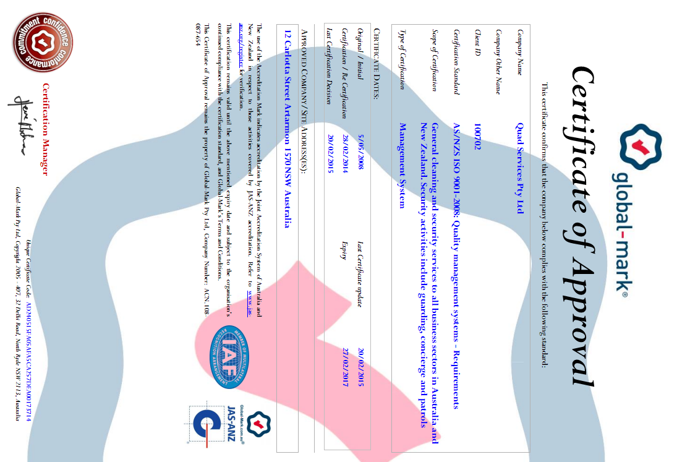

A consistent quality of service is maintained through the disciplined implementation of the Quad Operations Model.

## Quad Operations Model

The Quad Operations Model ensures the key elements are in place to achieve a consistent standard of service and client satisfaction.  This is achieved through;

* A disciplined adherence to this model
* Ongoing measurement of performance.
* Immediate response to and rectification of any defects, to client satisfaction.

**Consistent Quality Service**

**Close to client Immediate Response**

**Quad Operations Model**

**Flexible response**

**Customer Service Focus_____**

**Constant Measurement**

**1. OM Close by**

**2. Limited number**

**of OM sites**

**3. Right Site Set Up**

**4. Site Security**

**5. Ongoing Evaluation**

**& Training**

**6. GM & GGM oversight**

**Three Levels of offsite Management**

**7. OM/GM Authority**

**8. Audited Customised Inspections**

**9. CC & CLP Process**

**10. Communication Tools**

**14. Senior Management Review**

**13. Performance**

**Review with clients**

**12. Compliance Expertise & Review**

**11. Customer**

**Service Focus**

1. **An Operations Manager close by.**

The Operations Manager operates in a small geographical area which promotes quick and effective service. This enables the Operations Manager to:

* Spend more time at your site
* Support the onsite cleaning team, particularly when there are new or relief cleaners
* Provide immediate response to any client concerns or requests when required

1. **Limit the number of sites that the Operations Manager will serve.**

When the number of sites is exceeded within a region we create an adjacent operations area. Each operations manager has the time to effectively service each client site. Growth reinforces customer service; it does not detract from it.

1. **Right contract set up.**

The focus is on set up for long term client satisfaction, not short term profit.

* Select right cleaning personnel
* An effective ongoing supervision structure
* Effective scheduling of onsite labour hours with duty schedules to achieve agreed standards
* Ensuring the right equipment and materials

If these elements are not set up correctly, the result is client dissatisfaction and Operations Manager’s time spent resolving recurring issues.

1. **Site Security**

Security of client property is a prime objective.

* We meet with client representative to fully understand site security requirements including key security and doors which must be locked on departure
* All staff, supervisors and Managers are full trained on site security requirements and this is a key element of staff induction and training

1. **Ongoing staff evaluation and training**

At Quad our focus is regular assessment of cleaner competence to meet client site requirements. This involves:

* The provision of site specific induction for staff
* Training staff in all required technical aspects to perform their role
* Training staff in customer service and the appropriate response to client requests
* Ongoing refresher training and toolbox talks as a standard element of our procedures to ensure staff skills, and their understanding of site requirements, are current

1. **General Manager and Group General Manager oversight.**

* The regular contact by the General Manager also provides a second tier of senior offsite liaison for review of standards, and client contact
* Group General Managers and General Managers have a wide range and depth of cleaning experience to provide support for the Operations Manager
* These additional tiers of external management support ensures that ongoing external liaison and review is not disrupted by illness or absence, and that the site quality and service is reviewed regularly by more than one operations person
* Group General Manager for ongoing review of service quality and for additional offsite support.

1. **Operations Manager and General Manager authority**

The General Manager / Operations Manager team have the authority to make any necessary decisions to ensure customer satisfaction and rectify any omissions in service

1. **Audited customised inspection reports to ensure consistent ongoing standards**

* Inspection reports are customised to your specific site
* They are completed to an agreed inspection frequency which is monitored by our Compliance department
* Ongoing audit by the General Manager for accuracy of reporting

1. **Customer Care (CC) contact and ‘Close the Loop Process’ (CLP)**

* Each month our Customer Care team make a short call to your nominated site representatives to gauge their satisfaction with our service
* We initiate an immediate response to any client concerns. This involves the implementation of our ‘Close the Loop Process’. The steps in this process result in confirmation of client satisfaction on any issues raised
* The General Manager reviews any instances of client dissatisfaction and any issues that are not confirmed to be resolved with the client within 7 days
* This process keeps any client concerns / requests ‘in front’ of Quad senior management until full rectification to client satisfaction

1. **Communication**

* Communication tools include:
  + Onsite Communication Book
  + Operations team smart phone, tablet and laptop communication
  + Online CRM where clients can log and receive information
* Reporting:
  + Customised site reporting
  + Customised inspection reports kept in the CRM System for client access
  + Annual Action Plan for periodical work
  + Management Review Meeting reports for an overview of our performance against agreed standards

1. **Customer Service Focus**

Our prime focus is that our clients are satisfied with our service. All staff, cleaners, supervisors and managers are trained to focus our activities and adjust our service to meet client needs.

1. **Ongoing Compliance department review of Safety, Health, Environment and Quality**

* Quad has 3rd party accreditation of our management systems for Quality Assurance, Work Health & Safety and the Environment
* At Quad our aim is to provide a quality service within a framework of health and safety and environmental responsibility
* Our Compliance Department is constantly reviewing standards, and ensuring the operations management teams are compliant with current legislative requirements
* Each site has a Site Risk Control Plan that identifies all hazards associated with onsite activities. Safe Work Method Statements are provided for all these activities

1. **Effective Performance Review**

* The Management Review Meeting is in addition to regular site inspections and meetings. It is a pre-planned regular meeting with the client representatives with a structured agenda to assess, and report on, our performance
* The agenda is customised to suit your requirements. This facilitates:
  + Full review of our performance on a range of agreed criteria
  + Discussion of future changes required to our service
  + Adjustment of our service to changing client and/or site requirements

1. **Senior Management Review**.

* The CEO and Group General Manager receive daily reporting on any instance where client satisfaction is not being achieved. This is via the operations daily online reporting and the Customer Care process
* Each month the senior management team meet to evaluate:
  + WHS trends and data analysis
  + Client satisfaction data analysis
  + Instances of continuous improvement on client sites and how this can be applied to other sites
  + Team training, development and opportunities for promotion

***Our commitment to constantly measuring our performance  
 ensures compliance with these key criteria.***

## Issue Prevention and Resolution

The foundation of Quad ‘issue-resolution’ is threefold. First, having three levels of management, Operation Manager (OM), General Manager (GM) and Group General Manager of which a minimum of two are located close by to each site in small geographical areas enables us to respond quickly and effectively. The General Manager provides a second set of eyes for site inspections and also quickly intervenes if the Operations Manager does not achieve immediate issue resolution. Second, an operations culture of immediate issue resolution to meet varying client needs. Third, effective systems of regular Customer Care calls and inspection reporting that uncovers early signs of service lapses and initiates rectification before client concern develops.

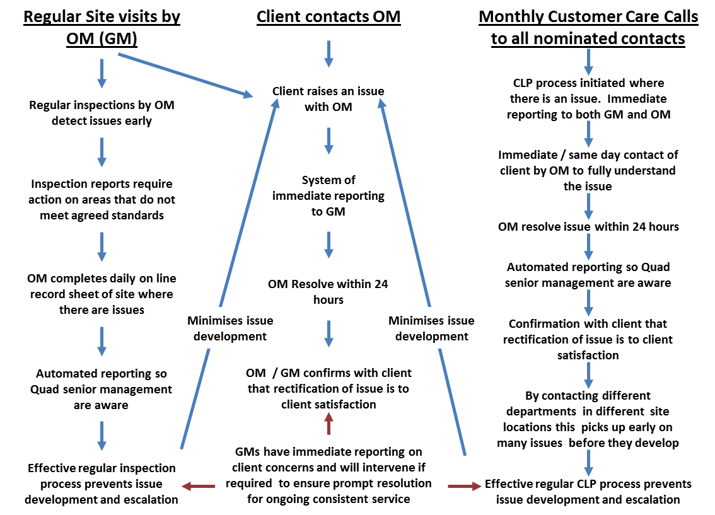

There are three ways our operations management become aware of site issues. (1) Our regular OM/GM site visits and inspections, (2) direct contact from your representative, and (3) our monthly customer care calls. These three elements identify issues early and lead to early resolution. Our system ensures senior management are aware of client concerns, and issues are quickly escalated to the GM and senior management if we are not meeting client requirements.

Communication Tools



**Site Staff**

**Communication Book**

**Operation Manager**

**& General Manager**

**Smart Phone & Tablet**

**Customer Care Team**

**Quad CRM**

**Client**



**Quad provides a range of communication tools to enable our clients to contact our staff and send or receive information.**

**Communication book**

* A communication book is provided for each contact point.
* It enables customers and our staff to communicate, even if they don’t see each other
* This enables speedy communication when the client does not think the Operations Manager needs to be involved.
* If there is a complaint about our services, the protocol for our staff is to attend to the issue immediately and inform the Operations Manager so that actions can be reviewed and client satisfaction confirmed.

**Local Operations Team**

* Operations Manager and the General Manager have smart phones and tablets for immediate email and phone communication.
* Tablets facilitate immediate online input into our database, including site inspections, training and Toolbox talks, Corrective Action Reports and Accident / Incident Reporting.
* This system enables data collection from all sites, on a range of activities which facilitates effective management review, prompt response to issues and reporting tailored to client requirements.

**Customer Care Team**

* Email and phone requests can be made directly to our Customer Care team. This initiates our Close the Loop Process to ensure monitoring until client satisfaction is confirmed.

**Quad CRM**

* Clients can log information and access reports and information directly through the Quad CRM. No paper reports are required and the client can access this at any time.

## Customer Care and Close the Loop Process (CLP)

Each month our customer care team makes a short call to the client nominated site representative. If there are any issues or requests they are immediately relayed to the operations team, and the customer care team makes a follow up call to ensure rectification to client satisfaction.

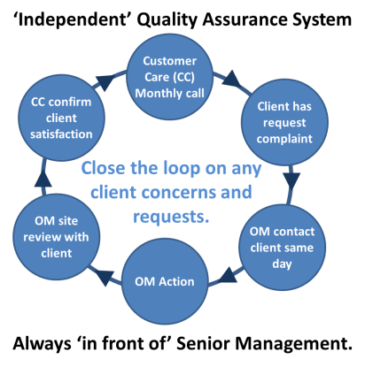

The CLP system provides the following benefits:

* It provides **early signals** of any lapses in service standards.
* The system ensures **immediate attention** to any issues. Early attention prevents minor issues developing into serious problems.
* It is a conduit for clients to **bypass normal operations** channels and any pattern of defects in a site or area is picked up and communicated to the General Manager and the CEO.
* Clients who are busy may not have the time to speak to the OM about an issue/request. At the monthly customer care call they often pass the message on to the customer care staff and the close the loop process ensures immediate rectification.
* Tenants and associate contacts can communicate with us directly so rectification can occur without taking up the time of the client representative. If required we can provide the client a record of these issues /rectifications each month.
* The complete process is **monitored by the Customer Care Manager** to ensure continued compliance.
* Our internal **daily CLP reporting system** keeps the issues/requests **‘in front’ of Quad senior management** until full rectification to client satisfaction.

## Onsite Operations and WHS Documentation

A copy of the documentation for the ongoing cleaning of your premises is located in the on-site Red Folder. This ensures that full information is always available to new cleaners and client representatives.

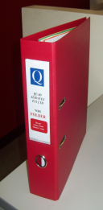

This folder includes:

* Emergency numbers and contact list.
* Staff Induction Information Booklet
* Quad policies
* Colour coding
* Safety registers
* Site Risk Control Plan (SRCP) & Site Environmental Management Plan (SEMP)
* Safe Work Method Statements (SWMS’s)
* Chemical Risk Assessments & Plant and Equipment Risk Assessments
* Incident/Accident Report Forms
* Chemical Safety Data Sheets (SDS’s)
* Site specifications, Annual Action Plan, Site Specific Requirements
* Equipment manuals
* Training information
* Safety Posters

During the start up, the contents of our Red Folder are discussed with your representatives to ensure customisation to site requirements

## Equipment and Materials

**Equipment**

* Equipment used on-site will be of the appropriate type and quality to ensure the cleaning requirements outlined in the cleaning specifications are met.
* All electrical equipment is tagged and tested to ensure compliance with Australian Standard AS/NZS 3760.
* Details of the equipment to be used at your site can be provided.
* We select equipment that is the most effective for each site. For instance where applicable:
  + Use of backpacks that are lightweight, ergonomic, have effective filtration systems for clean air, with noise levels below 70db.
  + Use of floor scrubber units that minimise power and water usage.
  + Floor polishers with suction to minimise dust.
  + Carpet spotting machines.
  + Janitor carts with bags.
  + Electric pressure cleaners.

Kerrick KD623 Pressure Cleaner.jpg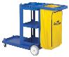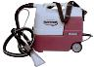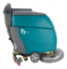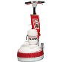

**Chemicals**



* Where possible we use chemicals that are environmentally friendly and approved by Good Environmental Choice Australia.(GECA)
* There is ongoing training to ensure safe chemical usage and correct dilution for effective cleaning while at the same time minimising chemical application to surfaces.
* Safety Data Sheets (SDS) are kept onsite for reference for all site chemicals.





**Micro Fibre technology for mops and cloths**

* That minimises the usage of water.
* Is more effective for cleaning.
* They are colour coded which assists in ensuring the correct cloths are used in different areas.

The Operations Manager and General Manager conduct regular audits of the cleaner rooms and of the cleaning operations to ensure compliance to WorkCover regulations and our equipment and materials usage polices.

## Training and Development

Quad places a strong emphasis on training and development. This includes:

* Structured training related to role requirements.
* Close support and monitoring until consistent competency is demonstrated.
* Prompt feedback when KPI are not being achieved.
* Ongoing refresher updates and improvement programs.

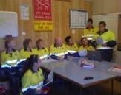**Cleaner training** is usually on site and in the form of talk box talks. This training emphasises the practical aspects of cleaning and includes:

* Basic skills.
* Advanced skills.
* Speciality cleaning, particularly related to site requirements.
* Security and site specific security protocols.
* WHS, environmental and site specific requirements.
* Sharps and first aid (basic) training where necessary.
* Where relevant certificate II – IV in Asset Maintenance (Cleaning Operations/Management).
* Where cleaning staff interact with client staff and the public then training includes customer service and dealing with situations that arise.
* Where children are on site the protocols for working in environments with children.
* The immediate removal of spills to prevent slips and falls.
* The use of signage to prevent patrons, staff etc from accidents while cleaning is in progress.
* Immediate reporting of any maintenance, security, cleaning or other issues to nominated client representatives
* Stocking of toilet supplies and toilet patrols to ensure consumables do not run out.
* Infection control and the use of colour coded materials to prevent cross contamination.

**Managers and Site Supervisors** have regular meetings for development which includes:

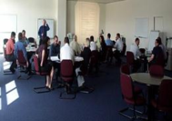

* Cleaner training and development.
* Cleaner selection and retention.
* Consistent Service – the Quad Operations Model.
* Site auditing and completing inspection reports.
* Industrial relations.
* WHS requirements, site and system audits and hazard identification.
* Customer service.
* Performance management including meeting SLAs and KPIs
* Site scheduling
* Environmental responsibility – Green cleaning.
* Continuous improvement.
* Effective use of Quads IT systems.

We have a large head office training facility. This enables groups to interact and have instruction in improvements or just refresher courses in their spheres.

We use external training partners in the training to certificate level. They develop and run any specialised training we require.

In addition to skill development relevant to role KPI, ongoing training provides employees with a sense of belonging to the Quad team and of contribution to the Quad team.

## Roles and Responsibilities

**Site Staff**

* Perform site tasks in accordance with specifications.
* Respond to ad-hoc service requests & emergencies.
* Daily review of communication book & immediate response /rectification.
* Strictly adhere to the security & safety measures.
* Report maintenance defects, security issues.
* Record figures for consumables & Waste & Recycling Management where applicable.
* Adhere to WHS procedures & immediately report any new hazards.
* Strictly adhere to environmental policies & minimise environmental impact

**Supervisors**

* Oversees site operations & ensure compliance with all contract specifications.
* Daily contact with & review of staff & activities, in particular detailed daily review of any new & relief staff.
* Daily supervision of high priority areas & random audits of quality standards.
* Daily review of communication book & ensures immediate response / rectification by site staff.
* Complete site inspection to designated frequency.
* Site induction & ongoing communication, consultation, appraisal & training of site staff. This includes competence in all site activities, WHS & environment requirements.
* Workplace Hazard identification & immediate contact with our WHS team to minimise risks in the workplace.
* Ensures the security measures on site are strictly adhered to & that all doors are locked to client requirements.
* Record figures for consumables & Waste & Recycling Management where applicable.
* Ensure compliance with WHS & environmental procedures.

**Operations Manager & Site Manager**

* Manages & controls the quality of service delivery & ensures compliance with all contract requirements.
* Ongoing contact with site managers, site supervisors & staff to ensure requisite equipment & materials are available.
* Regular contact with client representatives & immediate resolution of client requests or concerns.
* Site Managers maintain daily onsite contact with the client representative to address all requests & non-conformances immediately.
* Ongoing review & scheduling of site staff duties & responsibilities.
* Regular site inspections & review of site inspection reports.
* Review of service quality when any new & relief staff are introduced.
* Monthly review of site WHS compliance & hazard identification.
* Monthly review of environmental compliance.
* Ensures the security measures on site are strictly adhered to.
* Attends periodical management review meetings with client representatives.
* Monitors the work performance of all specialist subcontractors on site, to ensure they are adhering to Safe Work Method Statements & delivering a high level of service.
* Implement, monitor & review the site environmental management plan.
* Liaise with client regarding site WHS compliance & any WHS issues.

**General Manager- Operations**

* A second tier of regular senior offsite liaison for review of standards, & client contact (e.g. a more senior response to a request or concern).
* Monitors site performance & reviews site in the context of other sites for the potential of continuous improvement in different elements of our service delivery.
* Random site inspections.
* Works with all Operations Managers & site supervisors to ensure a full understanding of site requirements & the provision of adequate resources to meet agreed service levels.
* Ongoing local support for the Operations Manager & Site Managers.
* Immediate backup to ensure that service is not disrupted by illness or absence.
* Ensures compliance with all contract & legal requirements.
* Attends periodic Contract & Review Meetings with the Client’s representatives.
* Participates in negotiations & processes contract amendments & work authorisations.
* Six monthly full review of site WHS & Environment compliance & ongoing oversight that all staff & specialist contractors meet WHS & environment requirements.

**Group General Manager**

* Oversees standards & client satisfaction & ensures local teams meet client requirements.
* Attends periodic Contract & Review Meetings with the Client’s representatives.
* Regular meetings with the Local Operations Teams regarding ways to improve our service.
* Monthly meeting with the senior Management team to discuss site implementation of improvements & how this can be applied to other client sites.
* Liaison with WHS & Environmental specialists to monitor & review compliance in these areas.

**Compliance Manager**

* Oversee program to ensure communication & consultation with all workers regarding IMS systems & procedures, obligations & rights.
* Maintains Quad’s Quality Management strategy through the AS/NZS ISO 9001 certified Quality Management System (QMS)
* Supports Business Improvement (Continuous Improvement) & acts as a catalyst for change & improvement in performance/quality across Quad’s business
* Compile monthly reports on Quality Assurance & Quality Control system performance.
* Monitors the legal & operational aspects of safety, & designs appropriate systems to effectively respond to changes.
* Works with Operations & clients to develop & document procedures, standards, & systems to promote quality outcomes.
* Development of IMS training programs, & review of training program progress.

**Safety, Health, Environment & Quality (SHEQ) Manager**

* Ongoing development, implementation & continuous improvement of Quad’s AS4801 & ISO14001 WHS & Environmental Management Systems.
* Coordinates & liaises with Quad’s Safety Committee & the Client EHS Representatives.
* Conducts EHS risk assessments & updates Site Risk Control Plans in conjunction with Quad Operational Staff & from feedback from corrective action reports.
* Induction, training, & guidance of Quad staff in the implementation of EHS management systems.
* Assists the compliance manager in planning, organizing & implementation of EHS initiatives.
* Assists in the development & implementation of internal & external programmed & random audits.
* Develops & implements environmental strategies & action plans that ensure sustainable service provision & operation.
* Coordinates all aspects of pollution control, waste management, recycling, environmental health, conservation & renewable energy.
* Coordinate accident/incident investigations with local operations management.

**Customer Care Manager**

* Ensures all nominated site representatives are contacted each month by the customer care team.
* Reviews all responses & ensures that the ‘Close the Loop’ system is initiated where there are any client concerns or requests.
* Follows up with the local operations team if any client concerns / requests are not immediately rectified.
* Ensures senior management is kept informed when customer care follow up does not confirm client satisfaction.
* Ongoing monitoring of the close the loop system.

**Director Human Resources**

* Ensures compliance with the relevant Awards & Agreements.
* Institutes policies to ensure compliance with legislative requirements.
* Monitors the application of Quad HR & IR policies.
* Attends to employee & industrial relations matters.
* Maintains cordial relations with the relevant Unions.
* Sits on industry association/body committees to ensure up to date knowledge of all IR matters in industry.
* Resolve employee & industrial relations disputes to avoid client involvement.
* Coordinates return to work activities.
* Monitors new team member selection process to ensure appropriate role competency & that team member attitude aligns with Quad culture.
* Reviews job structure, role resourcing & staff wellbeing.
* Ensures that staff actions accord with Quad Policies.
* Report to CEO on resource requirements for effective achievement of Quality & EHS objectives.

**Chief Executive Officer**

* Responsible for ensuring that all elements of the Quality System are fully resourced, & function optimally in achieving the highest possible standards for compliance with the policies & procedures.
* Responsible for ensuring that all management and workers are sufficiently informed, trained and aware of their obligations.
* Delegates duties & responsibilities to appropriate specialists within the Quality team.
* Participates in major systems review meetings & monthly EHS and Quality Management meetings.

## Staff Uniforms & Identification

The Quad dress code is communicated to all staff at induction and there is ongoing review to ensure adherence to this dress code.

Quad has a range of apparel for different conditions. Below are some examples of uniforms and staff identification. In the start-up planning we present uniforms to the client representative for approval. These uniforms can be adjusted to meet site requirements.

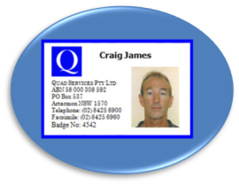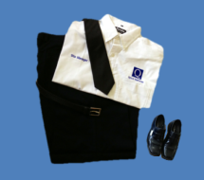

START UP PLANNING

**Site Start-Up Schedule**

|  |  |  |  |  |
| --- | --- | --- | --- | --- |
| Site: | | | | |
| Address: | | | | |
| Quad General Manager: Email: | | Mobile: | Email: | |
| Quad Operations Manager: | | Mobile: | Email: | |
| Quad Office email | |  | | |
| **PRE COMMENCEMENT** | | | | |
| **Date** | **Function** | | | **Responsibility** |
| Receipt of client acceptance | * Immediately advise Quad departments to initiate pre-commencement start-up, especially cleaner and / or supervisor selection and equipment decisions | | | * Contracts Officer |
| 4 weeks prior | * Meeting between Quad and client representatives:   + Introduction of Quad Operations Team to client.   + Tailor Site Start-Up Schedule to client requirements   + Confirm Quad start-up team.   + Order materials and equipment to be used on site. * Advise suppliers and specialist contractors of upcoming services | | | * Quad Business Development Person * Operations Manager * General Manager |
| 3 weeks prior | * Site Risk Assessment completed for WHS compliance. * Site environmental assessment * Obtain site specific security clearances for Quad management staff. | | | * SHEQ Manager * Operations Manager * General Manager |
| 2 weeks prior | * Quad administrative functions and resource allocations:   + Development of site customised reporting:     - Customise inspection report.     - Onsite operations manual (*Red Folder*)     - Develop yearly program of periodical work to be done   + Develop   + WHS Site Risk Control Plan (SRCP)   + Safe Work Method Statements (SWMS)   + Site Environmental Plan   + Confirm delivery of equipment and materials.   + Ensure SDS for chemicals provided by supplier   + Obtain security/ police clearances for cleaners | | | * Compliance Manager * SHEQ Manager * Operations Manager * General Manager |
| 1 week prior | * Meeting between Quad and client representatives:   + Introduction of Supervisor/ key cleaner where required.   + Review start-up progress and presentation of onsite operations manual (Red Folder).   + Confirmation of invoicing requirements   + Arrange area for equipment and materials storage when delivered day prior to commencement.   + Discuss and inspect any specific site requirements and/or areas that require special attention (particularly during changeover)   + Develop list of contacts for the monthly call from Customer Care Department * Provide cleaners (including any supplier and specialist contractors) with relevant training and WHS induction including a thorough understanding of any site specific safety requirements. | | | * Compliance Manager * Accountant * Operations Manager * General Manager |
| 1 day prior | * Meet with client representative for any final clarifications or review of service prior to commencement | | | * Operations Manager * General Manager |

| **COMMENCEMENT** | | |
| --- | --- | --- |
| **Date** | **Function** | **Responsibility** |
| Day one | * Deliver all materials, plant and equipment to your site(day prior if early morning start) * Set up cleaners’ room. * Supervision of cleaning during entire shift/s | * Operations Manager * General Manager |
| Day two - five | * Inspection of site in morning of days two and three. * Supervision of cleaning during entire shift/s * Full inspection of site at end of first week * Review and adjust cleaning tasks as necessary * Review SRCP and SWMS in relation to cleaner activities. | * Operations Manager * General Manager * SHEQ Manager |
| Week two | * Daily visit of site by either or both General Manager and Operations Manager * Inspection of various areas * Onsite monitoring (ongoing as required) * Present inspection report document for approval. * Full inspection of site at end of second week * Calls made to nominated site contacts by the Customer Care Department. * Review operation of Site Environmental Plan | * Operations Manager * General Manager * SHEQ Manager * Customer Care team |
| Week three | * Daily visit of site by either or both General Manager and Operations Manager * Adjustments and completion of the yearly program of periodical work * Review Red Folder * Onsite monitoring (ongoing as required) | * Operations Manager * General Manager * Compliance officer |
| Week four | * Review meeting with client representative. * Full inspection of site. * Presentation of periodic work program * Copies of inspection reports presented * Review of comments from nominated site contacts to the Customer Care department * Review of site specific requirements and areas that required special attention to ensure they are being addressed. * Organise program for on-going site inspections and review meetings. | * Operations Manager * General Manager |

This is a start-up schedule template. A customised start-up schedule will be created on receipt of your acceptance and presented to your representative for approval.

CONTRACT REPORTING

###### Contract Reporting Summary

**Inspection reports**

* We create a site customised inspection report in the second week of the start-up plan and this will be presented to your representative for review. This report will be amended in response to any feedback to produce an effective quality, safety and environmental inspection report. The inspection system is designed to ensure that:
* All areas are inspected to the agreed frequency usually at least monthly.
* Service quality, safety and environmental standards meet agreed service levels with a record of action taken where these are not met.
* Copies are kept on the CRM System for customer access.
* This inspection report will be adjusted in response to changing conditions. Whenever there is a change proposed, the Operations Manager will first seek the approval of your nominated representative.
* Reports are regularly audited by the General Manager. Site Supervisors and Operations Managers are fully aware that these inspection reports will be audited and that :
  + Inspections are completed to an agreed frequency.
  + Defects are rectified with date of rectification recorded on the inspection report.
  + Reports are always to be a true and accurate reflection of standards.

**Annual Action Plan**

* Attached is a sample site Annual Action Plan of all periodical work to be done.
* This is presented to your representative for review and is updated when required and a copy is kept in the CRM System.
  + The Annual Action Plan is:
  + A quality control mechanism to ensure all non-routine activities that have a frequency of less than once per month are reviewed and signed off when completed.
  + Information the client representative can access at any time to review the current situation with periodicals.

**Management Review meetings**

* + The Management Review meeting is in addition to normal inspections and meetings.
  + It is a pre-planned periodical meeting with the client representative with a structured agenda for full performance review of our service.
  + The agenda will be customised for your site requirements.

## Site Customised Inspection Report

|  |  |  |  |  |
| --- | --- | --- | --- | --- |
| **Prepared for:** | ACME Pty Ltd | | **Rating Guide:**  **Good = 4**  **Satisfactory = 3**  **Fair = 2**  **Poor = 1** | |
| **Located at:** | 123 Acme Street, Suburb | |
| **Date of Inspection:** |  | **Inspection cycle:** Fortnightly |
| **Area** | **Rating** | **Action Required** | | **Date Actioned** |
| **GROUND FLOOR :** |  |  | |  |
| **External :** |  |  | |  |
| External courtyard |  |  | |  |
| Car park |  |  | |  |
| **Internal :** |  |  | |  |
| Internal foyer |  |  | |  |
| Reception |  |  | |  |
| Waiting areas |  |  | |  |
| Customer services area |  | This is an example inspection report with an abbreviated area section. A full customised inspection report for your contract will be created in the start-up phase and presented to your representative for approval. | |  |
| Disabled toilet |  |  | |  |
| Male toilet |  |  | |  |
| Female toilet |  |  | |  |
| Lift lobby |  |  | |  |
| Lift |  |  | |  |
| Fire stairs |  |  | |  |
| Communication centre |  |  | |  |
| Open plan offices |  |  | |  |
| Enclosed offices |  |  | |  |
| Meeting room |  |  | |  |
| Utility room | Example Only |  | |  |
| Kitchen |  |  | |  |
| **1st Floor :** |  |  | |  |
| Carpet |  |  | |  |
| Tiles |  |  | |  |
| Lift lobby |  |  | |  |
| Fire stairs |  |  | |  |
| Reception |  |  | |  |
| Male toilet |  |  | |  |
| Female toilet |  |  | |  |
| Open plan offices |  |  | |  |
| Enclosed offices |  |  | |  |
| Meeting room 1 & 2 |  |  | |  |
| Boardroom |  |  | |  |
| Kitchen |  |  | |  |
| Lunch room |  |  | |  |
| Utility room |  |  | |  |

***~Truncated ~***

|  |  |  |  |  |  |  |  |  |
| --- | --- | --- | --- | --- | --- | --- | --- | --- |
| **WHS comments** | | | | | | | | |
| * Posters for Safety and Environment in Place and clearly visible. | | | | | | Y / N | | If N CAR must be raised |
| Red Folder reviewed and WHS system current and up to date. The following items must be completed with current information. | | | | Electrical equipment Register | | Y / N | | If N CAR must be raised |
| Chemical Register | | Y / N | |
| All SDS for site chemicals | | Y / N | |
| Incident Reports | | Y / N | |
| Induction Leaflet –site customised | | Y / N | |
| Toolbox Talks | | Y / N | |
| Site Risk Control Plan | | Y / N | |
| SWMS & Signed Register | | Y / N | |
| Check the following against storage area and items stored on site: | | | | | | | | If N CAR must be raised |
| * Cleaner room neat and tidy with items stored and labelled in designated areas. Ventilation is appropriate as required. | | | | | | Y / N | |
| * Equipment is stored as securely as practicable. Inoperative equipment is labelled and segregated. | | | | | | Y / N | |
| * Materials are stored safely. Chemicals are bottled and labelled | | | | | | Y / N | |
| * Drip Trays / bunding for chemicals | | | | | | Y / N | |
| * PPE for site activities & Safety signs in place | | | | | | Y / N | |
| * Colour coding system in place | | | | | | Y / N | |
| Any other CARs required? | Y / N | | Have all CARs been submitted to SHEQ Manager at the time of lodgement of this report with compliance. | | | Y / N | |  |
| Are there any new hazards that require review of the Site Risk Control Plan? | | | | | | Y / N | |  |
| Comments | | | | | | | | |
| **Environment. Comments & Observations regarding impact of the cleaning activities.** | | | | | | | | |
| Site activities meet requirements of the site environment plan. | | Site Environmental Management Plan | | | | Y / N | | If N CAR must be raised and submitted to SHEQ Manager |
| Waste Management Plan adhered to | | | | Y / N | |
| Microfibre usage | | | | Y / N | |
| Chemical usage | | | | Y / N | |
| Lighting – energy usage | | | | Y / N | |
| Equipment usage / noise | | | | Y / N | |
| Comments | | | | | | | | |
| **Overall standard & general comments** | | | | | | | | |
|  | | | | | | | | |
| **Items to raise with the client** | | | | | | | | |
|  | | | | | | | | |
| **Client comments** | | | | | | | | |
|  | | | | | | | | |
|  | | | | | | | | |
| Client’s Signature | |  | | | Date: | | / / | |
| Inspected by: | |  | | | Date: | | / / | |
| Reviewed by: | |  | | | Date: | | / / | |

## Annual Action Plan

|  |  |  |  |
| --- | --- | --- | --- |
| **Annual Action Plan** | | | |
| Month | **Periodical work** | **Date completed** | **Signed off by** |
| January | * Clean internal glass panels, partition doors & mirror * Strip & Seal vinyl floors |  |  |
| February |  |  |  |
| March | * Full wash of internal & external perimeter windows |  |  |
| April | * Clean internal glass panels, partition doors & mirror   Example Only |  |  |
| May |  |  |  |
| June |  |  |  |
| July | * Clean internal glass panels, partition doors & mirror * Strip & Seal vinyl floors |  |  |
| August | * Carpet shampoo common areas |  |  |
| September | * Full wash of internal & external perimeter windows |  |  |
| October | * Clean internal glass panels, partition doors & mirror |  |  |
| November |  |  |  |
| December |  |  |  |

This is a sample Annual Action Plan. A customised Annual Action Plan for your contact will be created in the start-up phase and presented to your representative for approval.

## Management Review Meetings

|  |  |  |  |  |  |  |
| --- | --- | --- | --- | --- | --- | --- |
| **CLIENT:** | **SITE ADDRESS:** | | | | **DATE:** | |
| **CLIENT REPRESENTATIVE(S):** | | | **QUAD REPRESENTATIVE(S):** | | | |
|  | | | | | | |
| **AGENDA ITEMS** | | **COMMENTS** | | **ACTION BY** | | **DUE DATE** |
| **Presentation and review of Inspection reports.** | |  | |  | |  |
| **Discussion items**   * **Cleaner Presentation** * **Cleaner communication** * **Cleaner performance** * **Site supervision** * **Manager attendance** | |  | |  | |  |
| **Discuss any areas/items of concern relating to service and proposed solutions to ensure rectification.** | | This is a template of a Management Review meeting agenda. This will be customised in the start-up phase and presented to your representative for approval. | |  | |  |
| **Review of specifications and any suggested changes to better reflect the site requirements and/or site changes.** | |  | |  | |  |
| **Review of the Annual Action Plan for periodical work. Confirm the months the service will be performed.** | |  | |  | |  |
| **Review of WHS issues and confirmation of Quad’s on-site compliance.** | |  | |  | |  |
| **Review of Environment issues and confirmation of Quad’s on-site compliance.** | |  | |  | |  |
| **Review any security issues/ concerns raised by client or advised by cleaners.** | |  | |  | |  |
| **Provide details of any maintenance /building defects advised by cleaners.** | |  | |  | |  |
| **Review of any suggestions for continuous improvement** | |  | |  | |  |
| **Other Comments** | |  | |  | |  |

###### 

QUAD SECURITY AND MAINTENANCE SERVICE

* + etc)

Security Services

Our experience in delivering security services to a range of organisations enables us to develop effective solutions to meet the individual requirements of each client.

Our security personnel provide a visible security presence, demonstrating a broad range of skills from general guarding to highly specialised security roles. Officers are fully trained, in line with client requirements and are branded with the Quad Services security logo and identification.

Regular site visits are conducted by the Managers to assess services, ensuring site policies are being carried out to provide regular reporting.

Quad can provide a range of security services and engage only qualified, licensed and professional Security Operatives.

**SECURITY MANPOWER SERVICES**

Security operatives for static guarding duties including RSA, RSG and Crowd Control.

**CONCIERGE SERVICES**

Professional Security customer service focused Operatives ensuring that egress and entry to corporate or licensed premises meets client requirements.

**LOSS PREVENTION OFFICERS**

Overt or covert operatives engaged in the retail sector, ensuring that all aspects of the law are followed when dealing with reduction of loss, as well as lawful detention of found offenders.

**CROWD CONTROL & EVENT PLANNING**

****Our security officers are trained and qualified to deal with the safety aspects of crowd control. We can assist with the strategic planning of events, and areas where the presence of security operatives are required to ensure the safe and effective methods to be used for controlling both small and large numbers of people.

**SECURITY PATROL SERVICES**

Our Patrol Operatives ensure client’s premises are appropriately secured, through checking physical barrier and internal checks.

**BACK TO BASE MONITORING**

Through associated contractors, this service is available to clients who have engaged the services of Quad Manpower Security at the site or complex, and when the area is sealed and closed, alarms activated then the monitoring of the Physical Barrier and Internal P.I.R. (Passive Infrared Detectors) is engaged.

Maintenance Services

We can provide licensed contractors and labour for all your building and maintenance needs. Our aim is to provide you with one point of contact for all your maintenance needs.

We also provide an out of business hours service. If the project requires work to be done within an office and disruption to your staff is an issue we can undertake the work out of hours.

******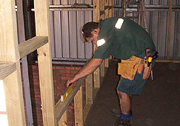****REFURBISHMENTS AND PROJECT MANAGEMENT**

Our trade’s people are qualified electricians, plumbers and carpenters and are capable of handling all types of refurbishments.

**CARPENTRY / CABINET WORKS**

Our carpenters take considerable pride in their workmanship so whether they are fixing a workstation, installing a partition a bench top, or removing a fixture to create more space you can be assured it will be done professionally and on time.

**STRIP OUTS**

Our tradesmen will enable a quick changeover for you in making good any minor damage, refurbishment, rubbish removal etc to ensure a smooth transition of your lease requirements.

**ELECTRICAL WORKS**

* Replacement / extra power outlets
* Exit Lighting/ compliance
* Electrical signage
* Data outlets
* Replacement and or extra lighting
* Lead Tagging.

**PLANNED AND REACTIVE MAINTENANCE**

Some examples where we assist clients are:

* Re-globing of lights, tubes upgrade
* Site inspections, roofing, exit signs.
* OHS compliance ;
* Fire inspections
* Landscaping upgrade and clearing
* Leaking taps/plumbing

**PAINTING**

Our team of qualified painters can provide the designed finish on time. We can supply colour charts and assist in colour selection where required.

**PLUMBING**

Our plumbers can be on call 24 hrs to repair and maintain your water services.

# AFFILIATIONS & AWARDS

###### Affiliations

|  |  |
| --- | --- |
|  | **Building Service Contractors Association of Australia (BSCAA)**  BSCAA is the recognised association for the cleaning services industry. Quad Services has been a member since 1989 and now sits on the executive committee |
|  | **Green Building Council of Australia (GBCA)**  Quad Services is a member of the Green Building Council of Australia. |
|  | **Property Council of Australia**  Quad Services is an Associate member. |
|  | **Clubs NSW**  Quad Services has maintained membership with Clubs NSW since 2000. |
|  | **Aged Care / Medical**  Quad Services is a member (Corporate supporter) of the Aged & Community Services Association of NSW & ACT |
|  | **Australian Security Industry Association Limited**  Quad Services is a Provisional Corporate Member of ASIAL. |
| FMA.jpg | **Facility Management Association of Australia (FMAA)**  Quad is a member of the Facility Management Association of Australia. |

###### Awards

### BSSCA Award 009.jpgBuilding Services Contractors Association of Australia Industry Awards

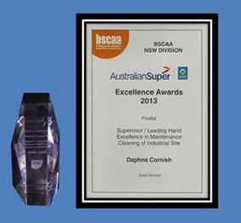

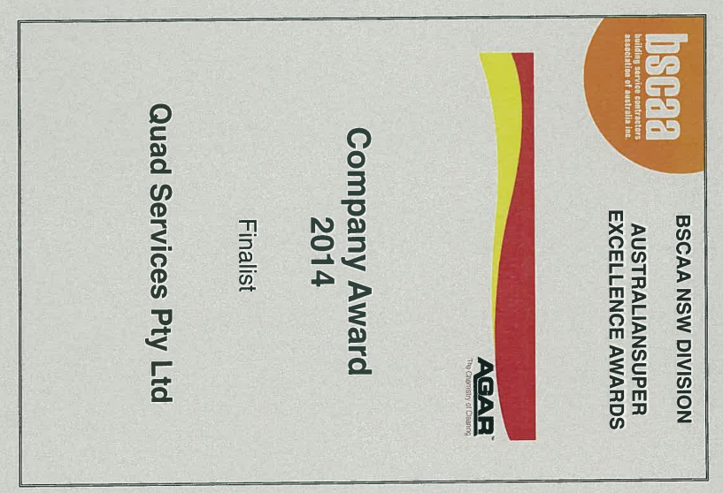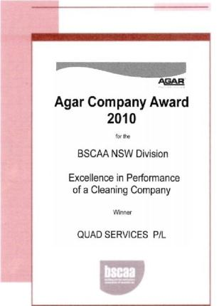

### Australian Achiever Awards

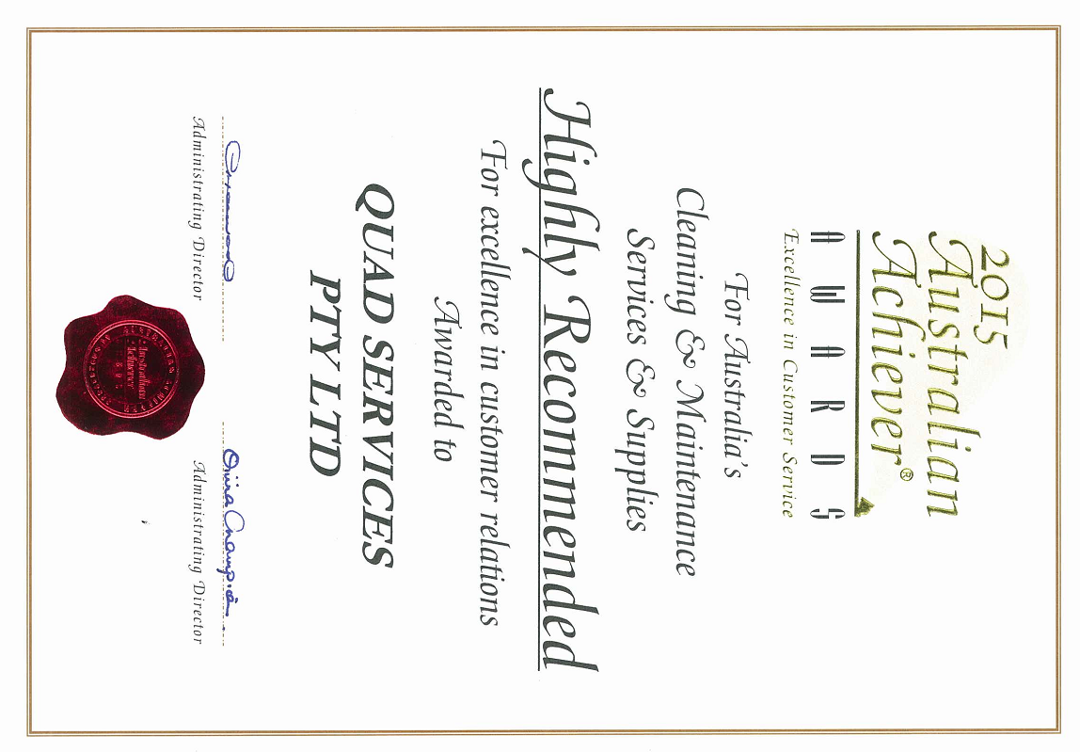

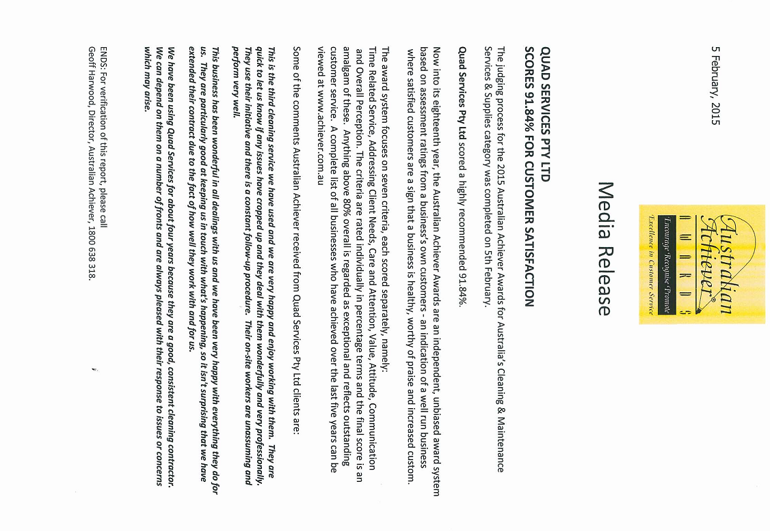

WHS INFORMATION AND ENVIRONMENTAL SUSTAINABILITY

WHS Accreditation

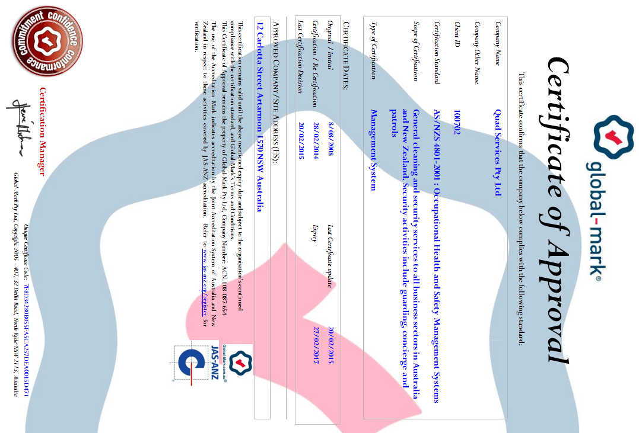

Quad is committed to maintaining the highest level of health and safety throughout the organisation. We are certified to AS/NZS 4801-2001: Occupational Health and Safety Management Systems. We believe that all injuries and industry related illnesses are preventable and we constantly strive to minimise such occurrences. To achieve this outcome we use the Quad WHS Management System outlined below:

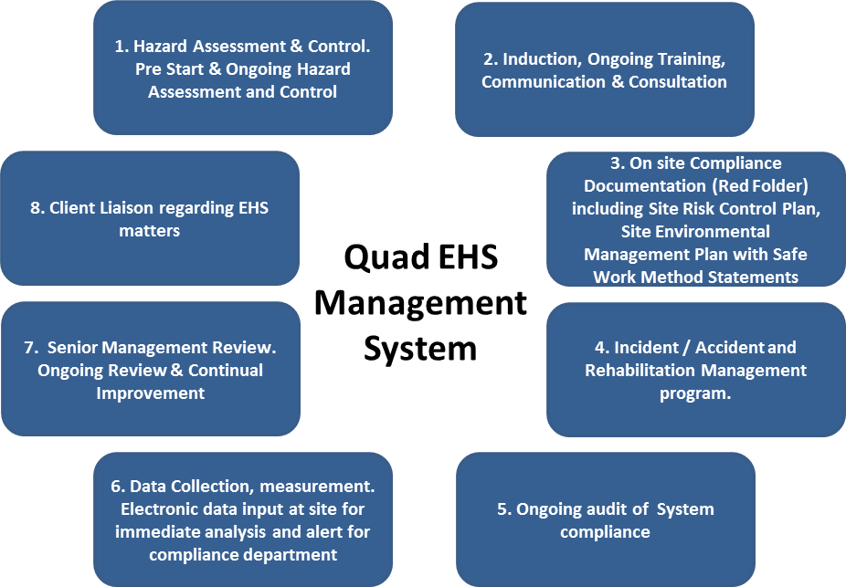

1. **Hazard Assessment & Control:**

* Prior to commencement of the contract, all site activities and hazards, including the equipment and cleaning chemicals, are reviewed to identify potential risks.
* The risks are assessed to allocate appropriate risk ratings and control measures.
* These hazards and their associated controls are integrated into key onsite documentation such as the Site Risk Control Plan (SRCP), Site Environmental Management Plan (SEMP) and Safe Work Method Statements (SWMS).
* Regular inspections and audits of the sites ensure our EHS procedures stay current and relevant.

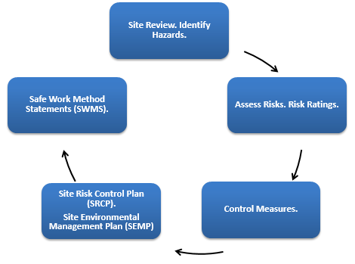

1. **Induction, Ongoing Training and Consultation:**

* There is effective communication, consultation, clear and easy to follow documentation to ensure all workers are fully aware of hazards and appropriate safe work procedures.
* Effective induction and ongoing training is provided in:
  + Hazard identification and reporting procedures;
  + Risk Mitigation and Minimisation
  + Incident / Accident procedures and reporting requirements;
  + Ongoing consultation, including regular ToolBox Talks.
  + Use of SRCP, SEMP, SWMS and other site EHS documentation.

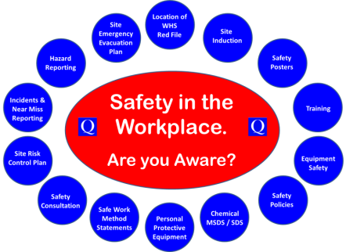

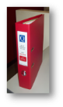

1. **Comprehensive EHS Onsite Documentation:**

The documentation required for the ongoing activities and maintenance of our EHS Management System at client sites is located in the onsite Red Folder. This is always available to our cleaners and client representatives. This WHS documentation includes:

|  |  |
| --- | --- |
| * Emergency numbers and contact list | * Chemical Risk Assessments & Plant and Equipment Risk Assessments |
| * Cleaner Induction Information Booklet | * Incident/Accident Report Forms |
| * Quad policies | * Chemical Safety Data Sheets (SDS’s |
| * Colour coding | * Site specifications, Annual Action Plan, Site Specific Requirements |
| * Safety registers | * Equipment manuals |
| * Safe Work Method Statements (SWMS’s) | * Training information |
| * Site Risk Control Plan (SRCP) & Site Environmental Management Plan (SEMP) | |

1. **Incident / Accident and Rehabilitation Management Program:**

* The policies and procedures in these areas are communicated to staff and are contained in:
* Incident / Accident and Injury Management Program
* Dispute resolution process
* Rehabilitation Program.

1. **Ongoing audit to ensure EHS Management System compliance:**

* All workers, supervisors and managers are trained in our EHS Management System requirements, including hazard identification, risk mitigation and minimisation, and non-conformance reporting for ongoing daily feedback on system compliance.
* Monthly audit of EHS Management System and worker compliance.
* Six monthly audits of all site hazards and review of SRCP, SEMP and SWMS.
* The SHEQ Manager regularly performs unannounced audits on sites to ensure the operations management teams are maintaining EHS standards and agreed procedures.

1. **Data Collection, Measurement and Improvement:**

* Each manager has a tablet which facilitates immediate online collection of data into our database, including site inspections, training and Toolbox Talks, Corrective Action Reports and Accident / Incident Reporting.
* This system enables data collection from all sites, on a range of activities which facilitates effective management review, prompt response to issues and reporting tailored to client requirements.

1. **Senior Management Review. Ongoing Review & Continual Improvement:**

* Quad’s EHS Management Committee meets monthly to review the EHS data and trends to ensure the system is functioning optimally, and to identify ways to improve our EHS Management System and outcomes.

1. **Client Liaison:**

* Ongoing liaison with client representatives relating to any site EHS issues.
* EHS reporting is an agenda item in our regular Management Review Meetings with clients.

**More details on our WHS system can be provided on request.**

Environment Accreditation

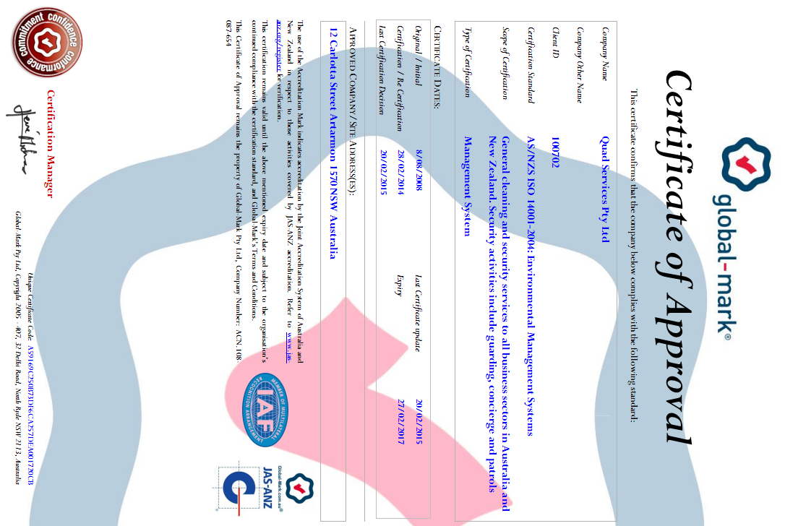

Quad is a member of Green Building Council of Australia and is committed to ensuring that our actions contribute toward a sustainable environment for current and future generations. We are certified to **AS/NZS ISO 14001-2004 Environmental Management Systems** which is integrated into our business planning at all levels of our organisation.

We also have a fully documented Environmental Policy Statement to ensure that all Quad staff understand our environmental objectives.

Our impact on the environment is in three spheres. Within each sphere we focus on the elements of our service delivery system that impact upon the environment.

**Right Products Right Staff Right Systems**

There are five key elements of environmental planning and management at Quad. Our aim is to identify, manage and measure the environmental impacts of these elements within the three sphere of our operations (i.e. Quad Offices, Field and Site Based Operations and the Quad Supply Chain).

* 1. **Purchasing**
* The environmental impact is a criterion for the purchase of materials. The use of microfibre technology is one example where the environmental benefits include, a significant reduction in the use of water and chemicals, and more effective cleaning which reduces the bacterial level and improves hygiene
* We work to reduce the volume of packaging and waste creation in our supply chain.
* Sourcing of goods and services locally to reduce the environmental footprint.
* Chemicals.The sustainable use of chemicals that are effective for the cleaning task yet are safe and biodegradable:
  + Where possible we use Good Environmental Choice Australia (GECA) certified products. Benefits include minimising cancer and reproductive health risk; minimising pollution; biodegrade quickly; contain no phosphorus and minimal sodium; and use minimal packaging.
  + We control the processes by which chemicals are used to minimise environmental impact.
  1. **Vehicles and Equipment**
* We select equipment that are effective for the purpose and environmentally sustainable. In particular equipment that minimises water and energy consumption, reduces noise levels, reduces dust emission levels and meets safety requirements.
* Movement toward the procurement of energy efficient vehicles or at a minimum smaller petrol efficient vehicles.
* Use of energy saving and efficient vehicles.
  1. **Waste Management and Recycling**
* Documented Waste and Recycling Management Plan for Quad offices. We recycle all paper, glass, metal, and plastic products and printer cartridges.
* Toolbox Talks and posters to provide effective communication to staff.
* Field staff awareness of client site waste management, recycling and reporting requirements.
  1. **Energy and Water**:
* Scheduling cleaning teams in a manner that minimises energy usage.
* Procurement of improved energy efficient office and site equipment.
* IT power mangement regimes for computer, printer and screens.
* Site staff and local management located close to client premises to reduce energy inputs.
* Our staff are trained be aware of good water management practices to conserve this valuable resource.
  1. **IT**
* The Quad CRM portal enables customers and Quad Operations Management to have online access to reports, reducing the need for paper-based reporting.
* All Quad site inspections and reporting are completed online which has resulted in a significant reduction in the use of paper and transmission / transportation of paper.
* Digital filing system, with storage of document digitally to save paper and minimise space for storage.
* Use of teleconferencing and Web conferencing to reduce travel requirements.

Underpinning the Quad environmental program are the following ongoing activities:

* Communication with clients, suppliers and staff regarding environmental policies and outcomes.
* Training including full site induction and ongoing Toolbox Talks about our environmental plan and processes to achieve these outcomes.
* Ongoing measurement of our performance.

**Thank you for the opportunity**

**to provide you with our proposal.**

Ian Saggus

Business Development Manager

(o) 02 8425 6900

(m) 0413 129 782

(e) isaggus@quadservices.com.au